Introduction:

Artificial Neural Networks (ANN) are algorithms based on brain function and are used to model complicated patterns and forecast issues. The Artificial Neural Network (ANN) is a deep learning method that arose from the concept of the human brain Biological Neural Networks. The development of ANN was the result of an attempt to replicate the workings of the human brain. The workings of ANN are extremely similar to those of biological neural networks, although they are not identical. ANN algorithm accepts only numeric and structured data.

What is Artificial Neural Network (ANN)?

An Artificial Neural Network (ANN) is a computational model inspired by the human brain’s neural structure. It consists of interconnected nodes (neurons) organized into layers. Information flows through these nodes, and the network adjusts the connection strengths (weights) during training to learn from data, enabling it to recognize patterns, make predictions, and solve various tasks in machine learning and artificial intelligence.

Artificial Neural Networks Architecture

1. There are three layers in the network architecture: the input layer, the hidden layer (more than one), and the output layer. Because of the numerous layers are sometimes referred to as the MLP (Multi-Layer Perceptron).

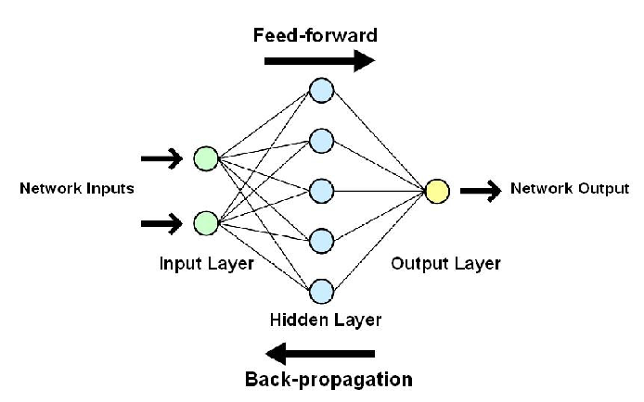

1. It is possible to think of the hidden layer as a “distillation layer,” which extracts some of the most relevant patterns from the inputs and sends them on to the next layer for further analysis. It accelerates and improves the efficiency of the network by recognizing just the most important information from the inputs and discarding the redundant information.
2. The activation function is important for two reasons: first, it allows you to turn on your computer.

* This model captures the presence of non-linear relationships between the inputs.
* It contributes to the conversion of the input into a more usable output.

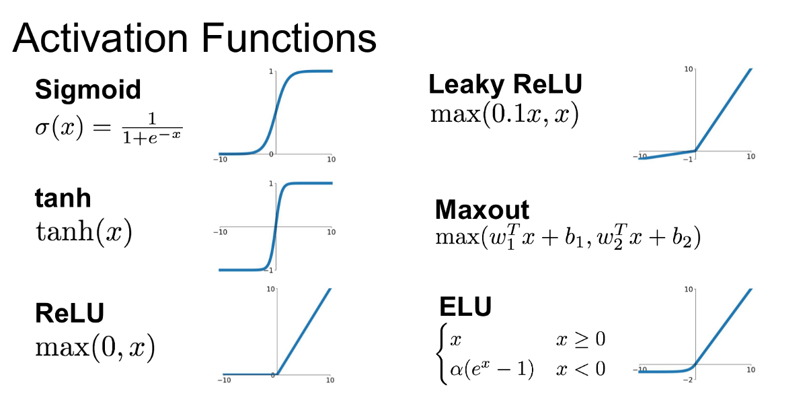

4. Finding the “optimal values of W — weights” that minimize prediction error is critical to building a successful model. The “backpropagation algorithm” does this by converting ANN into a learning algorithm by learning from mistakes.

1. The optimization approach uses a “gradient descent” technique to quantify prediction errors. To find the optimum value for W, small adjustments in W are tried, and the impact on prediction errors is examined. Finally, those W values are chosen as ideal since further W changes do not reduce mistakes.

Application of Artificial Neural Networks:

ANNs have a wide range of applications because of their unique properties. A few of the important applications of ANNs include:

**1. Image Processing and Character recognition:**

ANNs play a significant part in picture and character recognition because of their capacity to take in many inputs, process them, and infer hidden and complicated, non-linear correlations. Character recognition, such as handwriting recognition, has many applications in fraud detection (for example, bank fraud) and even national security assessments.

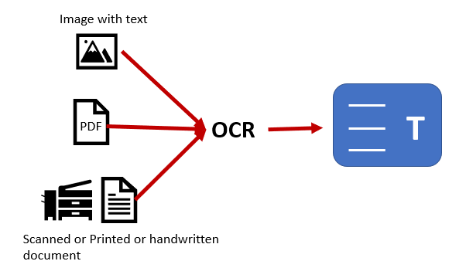

Image recognition is a rapidly evolving discipline with several applications ranging from social media facial identification to cancer detection in medicine to satellite image processing for agricultural and defence purposes.

Deep neural networks, which form the core of “deep learning,” have now opened up all of the new and transformative advances in computer vision, speech recognition, and natural language processing – notable examples being self-driving vehicles, thanks to ANN research.

**2. Forecasting:**

Forecasting is widely used in everyday company decisions (sales, the financial allocation between goods, and capacity utilization), economic and monetary policy, finance, and the stock market. Forecasting issues are frequently complex; for example, predicting stock prices is complicated with many underlying variables (some known, some unseen).



Traditional forecasting models have flaws when it comes to accounting for these complicated, non-linear interactions. Given its capacity to model and extract previously unknown characteristics and correlations, ANNs can provide a reliable alternative when used correctly. ANN also has no restrictions on the input and residual distributions, unlike conventional models.

**Advantages of Artificial Neural Networks**

Attribute-value pairs are used to represent problems in ANN.

* The output of ANNs can be discrete-valued, real-valued, or a vector of multiple real or discrete-valued characteristics, while the target function can be discrete-valued, real-valued, or a vector of numerous real or discrete-valued attributes.
* Noise in the training data is not a problem for ANN learning techniques. There may be mistakes in the training samples, but they will not affect the final result.
* It’s utilized when a quick assessment of the taught target function is necessary.
* The number of weights in the network, the number of training instances evaluated, and the settings of different learning algorithm parameters can all contribute to extended training periods for ANNs.

**Disadvantages of Artificial Neural Networks**

1. Hardware Dependence:

The construction of Artificial Neural Networks necessitates the use of parallel processors.

As a result, the equipment’s realization is contingent.

2. Understanding the network’s operation:

This is the most serious issue with ANN.

When ANN provides a probing answer, it does not explain why or how it was chosen.

As a result, the network’s confidence is eroded.

3. Assured network structure:

Any precise rule does not determine the structure of artificial neural networks.

Experience and trial and error are used to develop a suitable network structure.

4. Difficulty in presenting the issue to the network:

ANNs are capable of working with numerical data.

Before being introduced to ANN, problems must be converted into numerical values.

The display method that is chosen will have a direct impact on the network’s performance.

The user’s skill is a factor here.

5. The network’s lifetime is unknown:

When the network’s error on the sample is decreased to a specific amount, the training is complete.

The value does not produce the best outcomes.